Teaching Material

ConClip 5 • Airtightness:
Sealing around Cables & Ducts
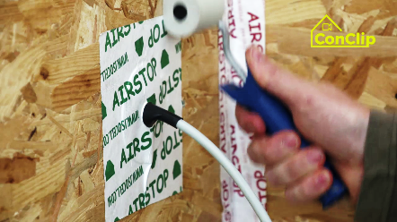 | 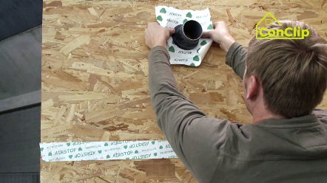 | 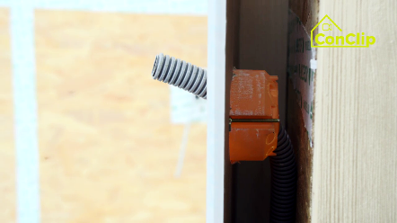

About ConClips
ConClips are short video clips (3 to 4 minutes) about the proper fitting of construction and installation parts in passive houses. As an easy understandable multimedia tool helping workers to fill skill gaps, ConClips can be integrated in vocational training and education.
The teaching material serves instructors and other experts as a basis for using ConClips in teaching that can be extended according to their own requirements.

ConClips: The making of
Each ConClip highlights one specific working process.
A worker performs the work steps in a realistic 1:1-scale model of the working environment.
An off-speaker gives short, understandable explanations to the work steps.
Additionally, the most important work steps and terms (keywords) appear as text inserts.
In the end, the most important steps and keywords are repeated.

Code of didactical practice
On the following page, you find material to the video, split in the following categories:
- The working procedure as shown in the video is divided into a sequence of comprehensible workflow steps
- The workflow steps are explained on three levels:
- What is done?
- How is it done?
- Why is it done?
- A small number of keywords relevant for the workflow are introduced and defined.
Please add the contents relevant for Your teaching – e.g. catchwords of explanation (Why something has to be done?) resp. keywords and a definition of them.
Workflow Steps
What is done? | How is it done? | Why is it done?
Sealing around cables & ducts:
Seal the joints between the panels with a suitable adhesive tape. | Use special tape designed for corners.
Drill the cable penetrations e.g. for sunscreen or temperature sensor | Keep the openings for switches, sockets and cables as small and as few as possible. | The less and the smaller the openings are, the better for airtightness of the timber frame construction.
 | Leave enough distance to the corners so that the sealing material has enough space.
Seal the cable with a cable sleeve. | For larger penetrations, like a pipe penetration passage, take a sealing sleeve with fitting diameter.
Manufacture an installation level – a layer between the inner wall and the vapour barrier containing the piping. | Build up the installation level after having attached the piping.
 | Slats are attached to the timber frame construction, then covered with the final wall surface. | The installation level minimizes penetrations of the outside layer and thus keeps the inside airtight.

Sealing around cables & ducts: KEywords
Airtightness | Building resp. envelope airtightness is the resistance to unintentional inward or outward air leakage in the building envelope. This air leakage is driven by differential pressures across the building envelope due to the combined effects of stack, external wind and mechanical ventilation systems.
Installation level | He installation level is a layer between the inner wall and the vapour barrier which contains the piping and cables.

