Teaching Material

ConClip 6 • Airtightness:
Sealing of Threshold Area
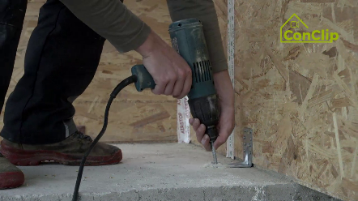 | 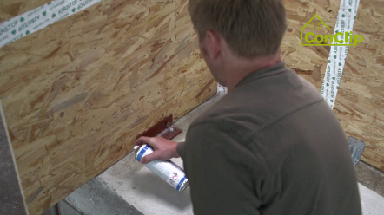 | 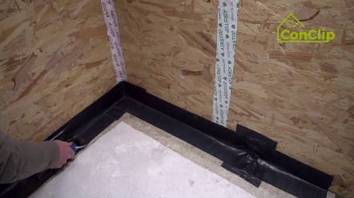

About ConClips
ConClips are short video clips (3 to 4 minutes) about the proper fitting of construction and installation parts in passive houses. As an easy understandable multimedia tool helping workers to fill skill gaps, ConClips can be integrated in vocational training and education.
The teaching material serves instructors and other experts as a basis for using ConClips in teaching that can be extended according to their own requirements.

ConClips: The making of
Each ConClip highlights one specific working process.
A worker performs the work steps in a realistic 1:1-scale model of the working environment.
An off-speaker gives short, understandable explanations to the work steps.
Additionally, the most important work steps and terms (keywords) appear as text inserts.
In the end, the most important steps and keywords are repeated.

Code of didactical practice
On the following page, you find material to the video, split in the following categories:
- The working procedure as shown in the video is divided into a sequence of comprehensible workflow steps
- The workflow steps are explained on three levels:
- What is done?
- How is it done?
- Why is it done?
- A small number of keywords relevant for the workflow are introduced and defined.
Please add the contents relevant for Your teaching – e.g. catchwords of explanation (Why something has to be done?) resp. keywords and a definition of them.
Workflow Steps
What is done? | How is it done? | Why is it done?
Sealing of threshold area:
Attach the wooden structure to the concrete floor by means of mounting brackets.
Tape the gap in the threshold area (between floor and wall) airtight. | First, pay attention that the surfaces are clean and dry.
 | Pre-treat the surfaces with primer. | The primer guarantees that the sealing tape adheres better.
 | Prefabricate the corner from sealing tape so that it fits exactly in the shape.
 | Use a roller or spatula in order to have sufficient and equal pressure on the sealing tape.
Before an internal wall is installed, it is necessary to first seal the horizontal joint with a short piece of sealing tape. |  | Internal walls are installed for reasons of stability before the sealing; the sealing tape on the floor avoids air leak.
The mounting brackets by which fix the wall to the concrete ground have to be sealed completely with tape. | Seal the large mounting brackets fixed on the ground by two layers of tape: The first is put vertically, then one horizontally.
 | The small mounting brackets also have to be covered completely with tape.
 |  | A well-sealed threshold area is the precondition for the next work step – the mounting of the inner walls.

Sealing of threshold area: KEywords
Airtightness | Building resp. envelope airtightness is the resistance to unintentional inward or outward air leakage in the building envelope. This air leakage is driven by differential pressures across the building envelope due to the combined effects of stack, external wind and mechanical ventilation systems.

