Teaching Material

ConClip 8 • Insulation:
Foundation skirting without basement
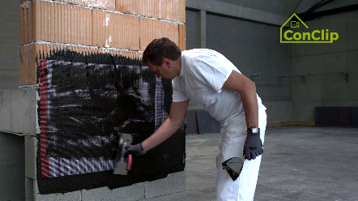 | 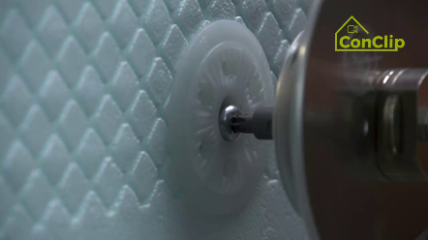 | 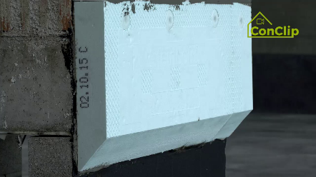

About ConClips
ConClips are short video clips (3 to 4 minutes) about the proper fitting of construction and installation parts in passive houses. As an easy understandable multimedia tool helping workers to fill skill gaps, ConClips can be integrated in vocational training and education.
The teaching material serves instructors and other experts as a basis for using ConClips in teaching that can be extended according to their own requirements.

ConClips: The making of
Each ConClip highlights one specific working process.
A worker performs the work steps in a realistic 1:1-scale model of the working environment.
An off-speaker gives short, understandable explanations to the work steps.
Additionally, the most important work steps and terms (keywords) appear as text inserts.
In the end, the most important steps and keywords are repeated.

Code of didactical practice
On the following page, you find material to the video, split in the following categories:
- The working procedure as shown in the video is divided into a sequence of comprehensible workflow steps
- The workflow steps are explained on three levels:
- What is done?
- How is it done?
- Why is it done?
- A small number of keywords relevant for the workflow are introduced and defined.
Please add the contents relevant for Your teaching – e.g. catchwords of explanation (Why something has to be done?) resp. keywords and a definition of them.

Workflow Steps
What is done? | How is it done? | Why is it done?
Foundation skirting without basement
For insulating the area below ground level, expose the foundation area sufficiently deep and wide. | Expose the foundation at least beyond frost depth of the area.  Make the cavity sufficiently wide to be able to work properly. | Buildings are subject to frost attack: Water turning to ice increases its volume and thus causes spalling of the material.
Close the transition between the foundation plate and the masonry with a bituminous sealing compound. | Let the sealing compound dry thoroughly before the next work step.
Insulate the wall beyond ground level with non-absorbent insulation boards. | Put the first row of insulation boards sufficiently deep below ground level, but at least in frost-proof depth.
 | Cut the boards at the bottom at an angle of 45 degrees.
 | The non-absorbent insulation boards are attached up to at least 30 centimetres above ground level.
 | For mounting the insulation boards, use a special adhesive mortar appropriate for bituminous underground.
Above the absorbent insulation boards, apply “conventional” insulation boards. | These boards are fixed with dowels. See ConClip 1 - Mounting of wall insulation boards.
Level out the façade.
Seal the foundation area with a sealing compound. | Seal the entire foundation area up to at least 30 cm above ground level.

Foundation skirting without basement: KEywords
Insulation | Especially in climates with a heating demand the entire building envelope has to be well insulated. The building envelope consists of all the building elements which separate the inside from the outside. Its main purpose is to provide for a comfortable indoor climate – irrespective of the outdoor climate which is determined by the weather.
Frost depth | Also frost line: The maximum depth at which soil is frozen in a certain area.

